**User:**

I am a Mechanical Designer, proficient in SolidWorks drafting, and a recent graduate of the University of New South Wales. I would like you to act as both a knowledgeable designer who can provide me with design expertise and a professional engineering designer who can act as a technical advisor to me when I have complex questions.

The equipment must comply with Australian Standards for Electrical Equipment. The design should be compact to fit into the limited urban space where the installation is specified. Considering the budget of A$50,000, we should prioritise durable materials, balancing cost and longevity.

Based on the above background, I will be designing an energy harvesting device.

The energy harvesting device shall require three key modules:

1. The energy accumulation module functions to derive energy from an external source outside the energy harvesting device.

2. The energy storage module functions to store the accumulated energy inside the energy

harvesting device.

3. The energy utilization module utilizes the harvested energy to power other small devices such as sensors, heating/cooling devices, actuators, and low-power devices.

Please give me as many and reasonable and complete designs as possible.

**GPT:**

Designing an energy harvesting device within your specified parameters is a complex yet exciting challenge. Let's break down the design aspects based on your requirements and the three key modules you've outlined.

**Energy Accumulation Module**

1. **Source of Energy**: Determine the source of energy your device will harness. Common sources include solar, wind, kinetic (motion), and thermal energy. Given the urban space constraint, solar panels or piezoelectric materials (which generate electricity from pressure or movement) could be ideal.
2. **Design Consideration**: Compact solar panels or piezoelectric materials can be integrated into urban infrastructure like pathways, building surfaces, or even public transportation facilities.
3. **Compliance**: Ensure the materials and design comply with Australian Standards, particularly for electrical safety and efficiency.

**Energy Storage Module**

1. **Battery Technology**: Lithium-ion batteries are a good choice for their balance of size, efficiency, and cost. Alternatively, consider supercapacitors for their fast charging and long cycle life.
2. **Integration**: The storage unit should be integrated seamlessly with the accumulation module, ensuring minimal energy loss during transfer.
3. **Safety and Durability**: Focus on robust casing and insulation to protect against urban environmental factors like temperature fluctuations, moisture, and physical disturbances.

**Energy Utilization Module**

1. **Output Regulation**: Incorporate a regulator or converter to adjust the energy output to the requirements of the connected devices (sensors, actuators, etc.).
2. **Connectivity**: Design modular connectors or wireless transmission capabilities (like RF or inductive coupling) for ease of connecting various devices.
3. **Control System**: Implement a smart control system to efficiently distribute power based on priority and demand, possibly integrating IoT for remote monitoring and management.

**General Design Considerations**

1. **Material Selection**: Use durable materials like stainless steel or reinforced plastics. Consider coatings or treatments for additional protection and longevity.
2. **Budgeting**: Allocate funds judiciously across components. High-quality batteries or solar panels might justify a higher upfront cost for long-term savings and reliability.
3. **Modularity and Scalability**: Design the device in a modular fashion so that it can be easily scaled or repaired.
4. **Aesthetics and Urban Integration**: Since it's for urban use, the design should be aesthetically pleasing and blend with the urban environment.
5. **User Interface**: If applicable, a simple user interface for maintenance or monitoring purposes would be beneficial.
6. **Prototyping and Testing**: Plan for prototypes and rigorous testing, especially for compliance with Australian Standards.
7. **Manufacturing Considerations**: Think about ease of manufacturing and assembly, keeping in mind the production costs.

This outline serves as a starting point for your design. Each module and aspect can be further detailed as you progress, ensuring all factors align with your specifications and standards. Remember, iterative design and testing are key in developing a functional and efficient energy harvesting device.

**User:**

Based on the information I provided earlier, are there any other details I should provide regarding the design of the energy harvesting device?

**GPT:**

To refine the design of your energy harvesting device, additional details can be crucial for a more targeted and efficient design process. Here are some aspects you might consider providing more information on:

1. **Specific Energy Source**: Clarify which energy source(s) you intend to harness. This will significantly influence the design of the energy accumulation module. For example, solar, kinetic, or thermal energy sources would each require different technologies and design approaches.
2. **Environmental Conditions**: More details about the specific urban environment where the device will be installed would help. Factors like average sunlight exposure, temperature ranges, humidity levels, and potential physical disturbances (like foot traffic or vehicle vibrations) are important for material and design decisions.
3. **Size and Space Constraints**: Exact dimensions or space limitations for the device installation would guide the compactness of the design.
4. **Target Devices for Energy Utilization**: Information about the types of devices the energy will power (their power requirements, connectivity needs, etc.) would aid in designing the energy utilization module.
5. **Maintenance and Accessibility**: Details about how the device will be maintained, who will have access to it, and how often maintenance is expected can influence the design, especially the user interface and modularity aspects.
6. **Aesthetic Requirements**: If there are any specific aesthetic considerations due to the urban setting or community preferences, these should be outlined.
7. **Regulatory Compliance Specifics**: More detailed requirements from the Australian Standards that need to be met, especially if there are unique or stringent regulations for your specific application.
8. **Longevity and Reliability Targets**: Specify your expectations for the device's lifespan and reliability standards.
9. **User Interaction Level**: If the device is intended to have any user interaction (beyond maintenance), details on how users would interact with it could influence design aspects like the user interface and safety features.
10. **Sustainability Goals**: If there are sustainability targets (like using recyclable materials or ensuring energy-efficient operation), these should be specified.
11. **Scalability Requirements**: If you plan to scale up the device in the future, knowing this upfront can impact the modularity and overall design approach.
12. **Budget Allocation**: Insights into how the budget is allocated (e.g., more towards durability vs. cutting-edge technology) could be useful.

Providing these details can lead to a more tailored and effective design, ensuring that the final product aligns closely with your specific needs and constraints.

**User:**

I like the minimalist and sleek design style of the energy harvesting device. It should look clean and modern without unnecessary details.

The energy harvesting device is planned to be deployed in a coastal urban environment in Australia. The design needs to take into account the city where it will be applied to ensure consistent energy output throughout the year. Installation must be straightforward. In terms of maintenance, the unit should be designed to minimise the need for frequent repairs and, where necessary, key components should be easily accessible.

Based on previous outputs and above information, please give me as many and reasonable and complete designs as possible.

**GPT:**

Creating a design for an energy harvesting device with a minimalist, sleek style suitable for a coastal urban environment involves several key considerations. Let’s explore various design approaches:

**1. Solar Energy Harvesting Device**

* **Design**: Slim, flat panels with a smooth, reflective surface for a modern look. The panels can be mounted on rooftops or integrated into urban structures like bus stops or benches.
* **Environment Consideration**: Corrosion-resistant materials to withstand coastal salt air. The panel angle should be adjustable to capture maximum sunlight year-round.
* **Maintenance**: Easy-to-clean surfaces and modular design for simple component replacement.

**2. Kinetic Energy Harvesting Device**

* **Design**: Sleek, ground-level tiles or panels that harness energy from pedestrian foot traffic. These could feature a simple geometric pattern in muted colors.
* **Environment Consideration**: Made from durable, non-slip materials suitable for a coastal climate. Must be water-resistant and able to withstand varying temperatures.
* **Maintenance**: Modular tiles for easy access and replacement, with self-cleaning surfaces to reduce maintenance.

**3. Wind Energy Harvesting Device**

* **Design**: Compact, vertical-axis wind turbines with a streamlined design. The turbines could be painted in colors that blend with the urban environment or in a single, striking color for a modern aesthetic.
* **Environment Consideration**: Salt and moisture-resistant materials; the design should ensure stability in strong coastal winds.
* **Maintenance**: Turbines designed for easy access to mechanical parts; minimal moving parts to reduce wear and tear.

**4. Hybrid Energy Harvesting Device**

* **Design**: A combination of solar and kinetic energy modules. Solar panels could be installed above kinetic tiles, creating a multi-functional structure.
* **Environment Consideration**: Materials selected for both solar and kinetic modules must be durable against coastal conditions. The structure should be designed to maximize energy capture from both sunlight and foot traffic.
* **Maintenance**: Separate access points for solar and kinetic components, ensuring easy maintenance without disturbing the entire system.

**General Design Features**

* **Aesthetics**: Clean lines, minimal visible screws or fastenings, and a smooth finish to emphasize a minimalist design.
* **Installation**: Design for ease of installation, possibly using prefabricated units or simple mounting systems.
* **Energy Efficiency**: Components optimized for maximum energy capture and storage, considering the varying sunlight and wind conditions in a coastal city.
* **Safety**: All designs must adhere to safety standards, especially considering public interaction in an urban setting.

Each design would be detailed with technical specifications, material lists, and diagrams to illustrate the assembly and integration of components. The designs would also include simulations or models showing the expected energy output and efficiency throughout the year in the specified coastal urban environment.

**User:**

Based on the design 1,2,3,4 you gave me above, please generate 4 visual concept diagrams.

**GPT:**

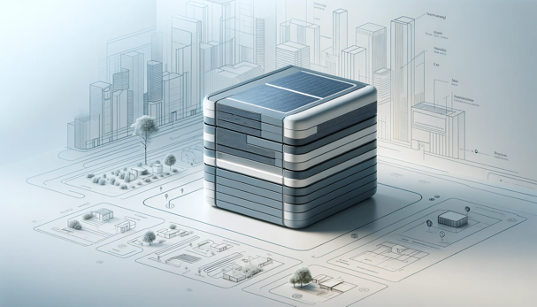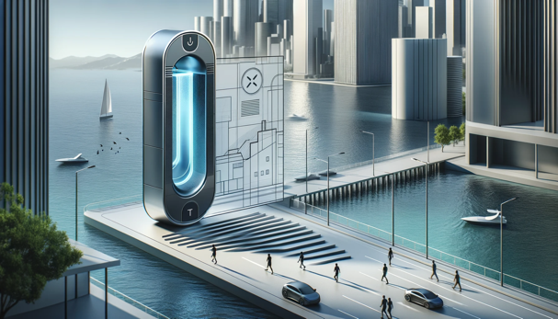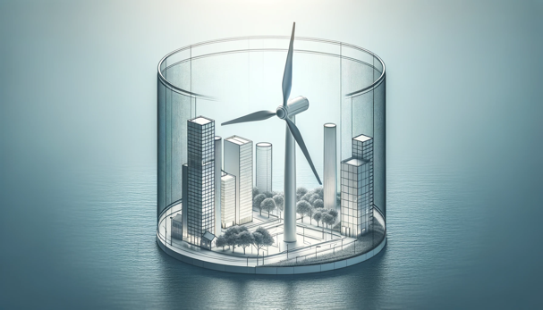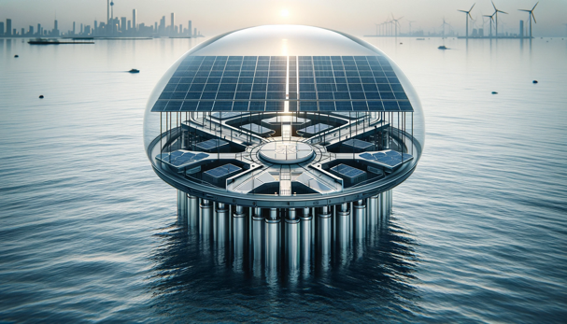

Here are the visual concept diagrams generated based on the designs provided:

1. For the **solar energy harvesting device**, we have a concept diagram that illustrates a modern, sleek unit with solar panels on the top surface, suitable for an urban coastal environment.
2. The **kinetic energy harvesting device** is integrated into pedestrian pathways, capturing energy from footsteps, designed with a contemporary and minimalist aesthetic.
3. An **innovative vertical-axis wind turbine** is depicted in a concept diagram that features a cylindrical, compact form factor, ideal for urban coastal spaces with modern, corrosion-resistant materials.
4. The **hybrid energy harvesting device** combines solar panels and kinetic floor tiles in a single compact, futuristic unit that showcases a stylish design suitable for harsh coastal urban conditions.

These diagrams are conceptual and serve as a visual starting point for further development and refinement in line with technical specifications and environmental considerations.